(Approx. 923 words)

Windows 8 - The Basics
By Howard Lewis, Program Coordinator, Midland Computer Club, MI
January 2013 issue, Bits and Bytes Newsletter
http://mcc.apcug.org/
lewis3ha (at) chartermi.net

With Microsoft’s release of Windows 8, there are a number of significant changes in the interface. Many people say that this is the biggest difference in the Windows interface since the release of Windows 95 in 1995 (which is forever in the world of technology). Part of the rationale for the change in the interface is to make a consistent interface between PCs, laptops, tablets, smartphones, etc. With this article, I will introduce some of the major concepts in the Windows 8 interface and will delve into some of the basic
usage issues.

Knowing that many of the current applications are desktop specific, Microsoft has two different types of interfaces built into Windows 8. The primary interface is the Start screen which is shown when Windows 8 is first started (Figure 1).

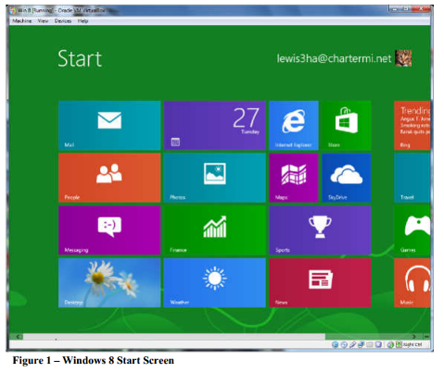

The Start screen contains Tiles which will launch Windows 8 specific apps. One of the unique things about these tiles is that they can be “live”. In other words, if you have a weather app running in Windows 8, the current temperature for a specific location will be displayed live. The same will be true of stock, sports scores, news, etc. The interface is designed for a touch interface, but can easily be navigated with a keyboard and mouse. The second interface is the Desktop screen (Figure 2). The Desktop screen looks (and is) very much like the very familiar Windows 7 interface. The one major difference is that the Start menu is missing (replaced by the Start screen).

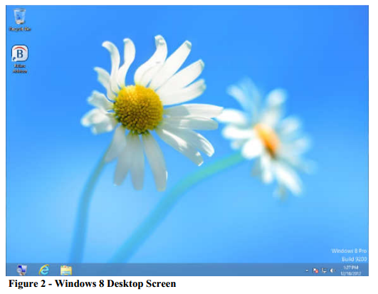

Almost all applications that have run under Windows versions since Windows XP will run in this mode. Most current Windows users will feel very much like they are working in Windows XP, Vista, or Windows 7. At this point, I probably spend 80% of my time in the Desktop. The default Start screen tiles include a tile (lower left Tile in Figure 1) to directly access Desktop mode for easy access. Any Windows applications not designed for Windows 8 will automatically run in Desktop mode. The major changes (and focus of this article) is the Start screen.

Those who are familiar with smartphones and using a touch device will probably have no problem navigating the Start screen interface. The problem is for those of us who are desktop- or laptop-centric. If you are using a mouse, the key focal points should be the corners of the screen.

Both the upper-right and lower-right corners bring up what is called the Charms bar (Figure 3) and it will be located on the right side of the screen. This bar includes Search, Share, Start, Devices, and Settings. All of these things were incorporated into the Start menu on previous versions of Windows. The Charms bar is available from both the Start screen and the Desktop.

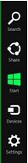
Fig. 3
Charms Bar

The upper-left corner brings up the App Switcher bar (Figure 4). This bar will be located on the left side of the screen. The App Switcher displays all apps that are currently running in either the Start screen or the Desktop and makes it easy to switch between various apps. The lower-left corner will allow you to switch between the Desktop and Start screens. The App Switcher is only available from the Start screen.

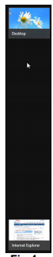
Fig.4
App Switcher

When you are on the Start screen or in a Windows 8 app, there are two other bars of interest, one at the top of the screen and one at the bottom. One or both of these bars will appear when you right-click in an app or on a tile. Both of these bars are app/Tile specific, but in certain apps the top bar is called the Places bar (Figure 5) and the bottom one is referred to as the App Menu (Figure 6).
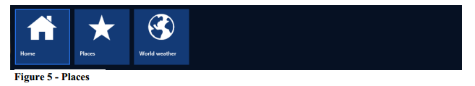

The Places bar allows you to specify information specific to an app, whereas the App Menu allows you to specify certain properties for a tile or app. All of these bars are dynamic and change depending on the focal point of Window 8.

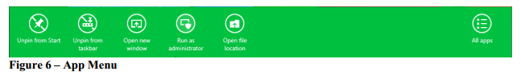
A couple of other important points that have perplexed various users. Windows 8 was originally designed for the computer to not normally Shutdown and therefore would not be turned off. Most modern devices (tables, smartphones, etc.) run using very low power processors, so they can run for 10+ hours without being connected to power, plus they also go to sleep very easily to conserve battery. Many people from
the desktop/laptop world are used to turning their computers off periodically and will want to continue to do Shutdowns. To accomplish this, simply go to the Charms bar, Settings, Power. From here you can shut down or restart the computer.

Another frequent question is how to close a Windows 8 app (Desktop apps close in the normal manner by clicking the “x” in the upper-right corner of the window). Most Windows 8 apps are designed to run in the background at all times, much like an iPad, etc. Since Windows 8 apps don’t have an ”x” in the upper-right corner to close the app, you close the app by taking the cursor to the top edge of the screen where the
cursor will change to a hand. Now click and drag to the bottom of the screen. This will close the app.

In future articles, I will cover various shortcuts and tips for making Windows 8 even easier.

